Movie Trivia
1. This equation was a plot point in what space-related movie?
a. Gattaca
b. 2001: A Space Odyssey
c. Apollo 13
*d. October Sky
e. Space Cowboys
2. The car in this picture from Back to the Future was produced by what car company?
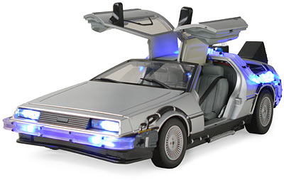
a. Chevrolet
b. Datsun
c. Nissan
*d. DeLorean
e. Toyota
Type: E
3. In one sentence, write your opinion of the 1994 film, Dumb and Dumber.
Type: F
4. How many degrees of separation is every person purported to be from actor Kevin Bacon?
a. six
b. Six
c. 6
Type: MT
5. Match the following directors with their movies:
a. Steven Spielberg=E.T.
b. James Cameron=Avatar
c. Coen Brothers=Fargo
d. Martin Scorsese=Taxi Driver
e. Woody Allen=Annie Hall
f. Mel Brooks=Young Frankenstein
Type: MA
6. Which of the following films were made in the 1990s? (you may choose more than one).
*a. Shawshank Redemption
*b. Tommy Boy
c. The Lord of the Rings: Fellowship of the Ring
*d. The Matrix
*e. Silence of the Lambs
7. The highest-grossing film of all time is James Titanic.
a. True
*b. False
8. Identify the movie from the sound clip below:
a. Star Wars Episode VI: Return of the Jedi
*b. Star Wars Episode V: The Empire Strikes Back
c. Star Wars Episode I: The Phantom Menace
d. Star Wars Episode IV: A New Hope
e. Star Wars Episode II: Attack of the Clones
Type: F
9. Watch the video clip below from the movie Inception. The young woman, known as the "architect" in the clip, was played by what actress?
a. Ellen Page
b. ellen page
c. Ellen
d. Page

